Name
Class
Class no.
Date
Marks | / 50
Carmel Holy Word Secondary School
2024-2025 Term 2
Secondary 3 Computer Literacy
Practical Mock
Time: 45 Minutes

- Write your Name, Class and Class Number in the boxes provided.
- Follow the instructions below to finish the examination tasks.
- If you fail to upload your work, NO MARK will be given.

- ALL TASKS should be finished in VS Code.
- Login to Teams and open a folder named “S3 Term 2 Practical Mock”.
- Download the files “task2_2425.py”, “task3_2425.py” and “task4_2425.py” to your computer.
- Submit your work to the suitable assignments in Teams.

Task 1 (10 marks)
Write a program to produce the output shown in Figure 1 for Task 1.
(a) Create a Python file in VS Code and name it “task1_2425.py”.
- Ask the user to input their name.
- Ask the user to input their age.
- Calculate the year they will turn 100 years old.
- Print the name and the calculated year (As Figure 1 has shown).
- Save the file as “task1_2425.py” and submit it to Teams.

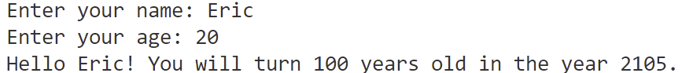

Figure 1

Task 2 (10 marks)
Write a program to produce the output shown in Figure 2 for Task 2.
(a) Download “task2_2425.py” from Teams and open it in VS Code.
(b) Create an empty list to store the input number
(c) Ask user to input a number
(d) Convert the input string into an integer.
(e) Complete the if-elif-else condition.
- Check whether the input number is -1 or not
- If the input number is -1, stop the loop
- If the input number is greater than 0, add the number to the list
- If the input number is either -1 or greater than 0, print out the number and tell the user that the number is lower than 0 (As Figure 2 has shown).
(f) Print the positive number saved in the list (As Figure 2 has shown).
(g) Save the file as “task2_2425.py” and submit it to Teams

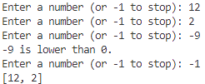

Figure 2

Task 3 (15 marks)
Write a program to produce the output shown in Figure 3 for Task 3.
(a) Download “task3_2425.py” from Teams and open it in VS Code.
(b) Import the library.
- Line 2: Speech Recognition library
(c) Speech Recognition: Set up the recognizer and the microphone
- Line 6: Set up the recognizer
- Line 7: Set up the microphone
(d) Speech Recognition: Detect user speech
- Line 17: Adjust the speech to cancel noises
- Line 18: Listen to user speech
- Line 21: Recognize user speech in English and output as text
(e) Print all the texts saved in the list
(f) Save the file as “task3_2425.py” and submit it to Teams.

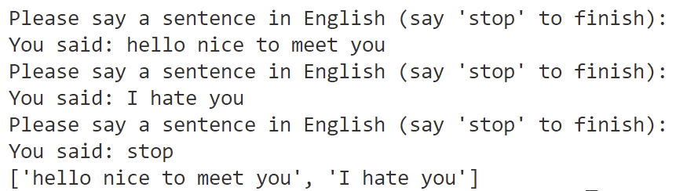

Figure 3

Task 4 (15 marks)
Write a program to display an image or a video.
(a) Download “task4_2425.py” from Teams and open it in VS Code.
(b) Import the OpenCV library
(c) Loading an image
- Line 13: Read the image file “face.jpg”
- Line 14: Show it as a window
- Line 15: Wait until any key is pressed to close the window
(d) Loading a video
- Line 19: Open the video file “video.mp4”
- Line 21: Read one frame from the video
- Line 22 - 23: Create an if condition to check if the video was playing or not; if not, stop video
- Line 24 – 25: Show the video
(e) Save the file as “task4_2425.py” and submit it to Teams.

End of Paper

Appendix: Modules and Functions API Reference Table
Module | pip install | Example of Import Statement
gTTS | gTTS | from gtts import gTTS
Playsound | playsound==1.2.2 | from playsound import playsound
Google Cloud Translate | google-cloud-translate==2.0.1 | from google.cloud import translate_v2 as translate
Speech Recognition | SpeechRecognition | import speech_recognition as sr
OpenCV | opencv-contrib-python | import cv2

Module | Description | Function Example
gTTS | Setup gTTS | audio = gTTS(text="I Love You", lang="en")
gTTS | Save TTS audio to a file | audio.save("audio.mp3")
Playsound | Play the audio file | playsound("audio.mp3")
Google Cloud Translate | Initialize the translation client | client = translate.Client()
Google Cloud Translate | Translate text between languages | result = client.translate(text, source_language="en", target_language="zh")  print(result["translatedText"])
Speech Recognition | Create a Recognizer instance | recognizer = sr.Recognizer()
Speech Recognition | Initialize microphone input | mic = sr.Microphone()
Speech Recognition | Calibrate for ambient noise | recognizer.adjust_for_ambient_noise(source)
Speech Recognition | Listen and capture audio input | audio = recognizer.listen(source)
Speech Recognition | Convert audio to text using Google | text = recognizer.recognize_google(audio, language="en")
OpenCV | Read an image file | image = cv2.imread("face.jpg")
OpenCV | Open a video file or camera stream | cap = cv2.VideoCapture("video.mp4")
OpenCV | Read a frame from the video | isTrue, frame = cap.read()
OpenCV | Display the video frame in a window | cv2.imshow('Video', frame)
OpenCV | Wait for a key event (with delay) | cv2.waitKey(1)

